Problem (1):
Source Code:
Network.py
import torch.nn as nn
import torch.nn.functional as F

class Network(nn.Module):

def __init__(self, n_observations=4, n_actions=2):
super(Network, self).__init__()
self.layer1 = nn.Linear(n_observations, 128)
self.layer2 = nn.Linear(128, 128)
self.dropout = nn.Dropout()
self.layer3 = nn.Linear(128, n_actions)

def forward(self, x):
x = F.relu(self.layer1(x))
x = self.dropout(x)
x = F.relu(self.layer2(x))
return self.layer3(x)

ActorCritic.py
import torch.nn as nn

class ActorCritic(nn.Module):
def __init__(self, actor, critic):
super().__init__()
self.actor = actor
self.critic = critic

def forward(self, state):
action_pred = self.actor(state)
value_pred = self.critic(state)
return action_pred, value_pred
CartPoleA2C_1147129.py
import sys
import gymnasium as gym
import math
import random
import matplotlib
import matplotlib.pyplot as plt
from collections import namedtuple, deque
from itertools import count
import torch
from Network import Network
from ActorCritic import ActorCritic
import torch.optim as optim
import torch.nn as nn
import os
from time import sleep
import numpy as np
import torch.nn.functional as F
import torch.distributions as distributions

env = gym.make("CartPole-v1")
test_env = gym.make('CartPole-v1')

#plt.ion()

# if GPU is to be used
device = torch.device("cuda" if torch.cuda.is_available() else "cpu")

MAX_EPISODES = 500
GAMMA = 0.99 # discount factor
N_TRIALS = 25
REWARD_THRESHOLD = 400
PRINT_EVERY = 10
LR = 0.001

train_rewards = []
test_rewards = []

def main():
#n_actions = env.action_space.n
## Get the number of state observations
#state, info = env.reset()
#n_observations = len(state)

#actor = Network(n_observations, n_actions).to(device)
#critic = Network(n_observations, 1).to(device) # critic has single output for V

#policy_net = ActorCritic(actor, critic).to(device)

#optimizer = optim.AdamW(policy_net.parameters(), lr=LR, amsgrad=True)

#res = train(policy_net, actor, critic, optimizer) # -------uncomment this line to train network

#print("----------saving model in file-----------------")
#checkpoint_data_policy = {
# 'epoch': MAX_EPISODES,
# 'state_dict': policy_net.state_dict(),
#}
#ckpt_path = os.path.join("checkpoint/CartPoleA2C_policy_model.pt")
#torch.save(checkpoint_data_policy, ckpt_path)

# after model is trained, use the following code to play
model = load_model('checkpoint/CartPoleA2C_policy_model.pt',device)
play(model) # play one game against trained network

def load_model(path: str, device: torch.device): # load trained model
n_actions = env.action_space.n
state, info = env.reset()
n_observations = len(state)
actor = Network(n_observations, n_actions).to(device)
critic = Network(n_observations, 1).to(device) # critic has single output for V
model = ActorCritic(actor, critic).to(device)
checkpoint_data = torch.load(path)
model.load_state_dict(checkpoint_data['state_dict'])
model.eval()
return model

def play(model):
#----------test trained model-----------
env = gym.make('CartPole-v1',render_mode="human")
env.reset()
state = env.reset()
for _ in range(200):
action = select_action_play(model, state)
state, reward, done, _,_ = env.step(action)
env.render()
sleep(0.1)
env.close()

def train(policy_net, actor, critic, optimizer):
for episode in range(1, MAX_EPISODES+1):
policy_loss, value_loss, train_reward = train_one_episode(policy_net,
actor, critic, optimizer, GAMMA)
test_reward = compute_reward_one_episode(policy_net)
train_rewards.append(train_reward)
test_rewards.append(test_reward)
mean_train_rewards = np.mean(train_rewards[-N_TRIALS:])
mean_test_rewards = np.mean(test_rewards[-N_TRIALS:])
if episode % PRINT_EVERY == 0:
print(f'| Episode: {episode:3} | Mean Train Rewards:{mean_train_rewards:5.1f} | Mean Test Rewards: {mean_test_rewards:5.1f} |')
if mean_test_rewards >= REWARD_THRESHOLD:
print(f'Reached reward threshold in {episode} episodes')
break
plot_rewards(train_rewards, test_rewards)

def compute_reward_one_episode(policy_net):
policy_net.eval()
done = False
episode_reward = 0
state = test_env.reset()[0]

while not done:
state = torch.FloatTensor(state).unsqueeze(0).to(device)
with torch.no_grad():
action_pred,_ = policy_net(state)
action_prob = F.softmax(action_pred, dim = -1)
action = torch.argmax(action_prob, dim = -1)

state, reward, done, _, _ = test_env.step(action.item())
episode_reward += reward
return episode_reward

def train_one_episode(policy_net, actor, critic, optimizer, discount_factor):
policy_net.train()
log_prob_actions = []
rewards = []
values = []
done = False
episode_reward = 0
state = env.reset()[0]
while not done:
state = torch.FloatTensor(state).unsqueeze(0).to(device)
action_pred = actor(state)
value_pred = critic(state)
action_prob = F.softmax(action_pred, dim = -1)
dist = distributions.Categorical(action_prob)
action = dist.sample() # will return 1 or 0 - for CartPole, only two actions
log_prob_action = dist.log_prob(action)
state, reward, done, _, _ = env.step(action.item())
log_prob_actions.append(log_prob_action)
values.append(value_pred)
rewards.append(reward)
episode_reward += reward
log_prob_actions = torch.cat(log_prob_actions)
values = torch.cat(values).squeeze(-1)
discounted_rewards = calculate_discounted_rewards(rewards, discount_factor)
advantages = calculate_advantages(discounted_rewards, values)
policy_loss, value_loss = update_policy(advantages, log_prob_actions,discounted_rewards, values, optimizer)
return policy_loss, value_loss, episode_reward

def calculate_advantages(discounted_rewards, values, normalize = True):
advantages = discounted_rewards.to(device) - values.to(device)
if normalize:
advantages = (advantages - advantages.mean()) / advantages.std()
return advantages

def calculate_discounted_rewards(rewards, discount_factor, normalize = True):
returns = [] # apply the discounted rewards to the episode state actions
R = 0
for r in reversed(rewards):
R = r + R * discount_factor
returns.insert(0, R)
returns = torch.tensor(returns)
if normalize:
returns = (returns - returns.mean()) / returns.std()
return returns

def update_policy(advantages, log_prob_actions, discounted_rewards, values,
optimizer):
# updates the policy network
policy_loss = - (advantages * log_prob_actions).sum()
# - sign makes the maximization problem to minimization
value_loss = F.smooth_l1_loss(discounted_rewards.to(device), values.to(device)).sum()

optimizer.zero_grad()
policy_loss.backward(retain_graph=True)
value_loss.backward()

optimizer.step()
return policy_loss.item(), value_loss.item()

def plot_rewards(train_rewards,test_rewards):
plt.figure(figsize=(12,8))
plt.plot(test_rewards, label='Test Reward')
plt.plot(train_rewards, label='Train Reward')
plt.xlabel('Episode', fontsize=20)
plt.ylabel('Reward', fontsize=20)
plt.hlines(REWARD_THRESHOLD, 0, len(test_rewards), color='r')
plt.legend(loc='lower right')
plt.grid()
plt.show()

def select_action_play(model, state):
if len(state) != 4:
state = state[0]
state = torch.Tensor(state).to(device) # added [0]
with torch.no_grad():
action_pred,_ = model(state)
action_prob = F.softmax(action_pred, dim = -1)
action = np.argmax(action_prob.cpu().numpy())
return action

if __name__ == "__main__":
sys.exit(int(main() or 0))

Output & Discussion:

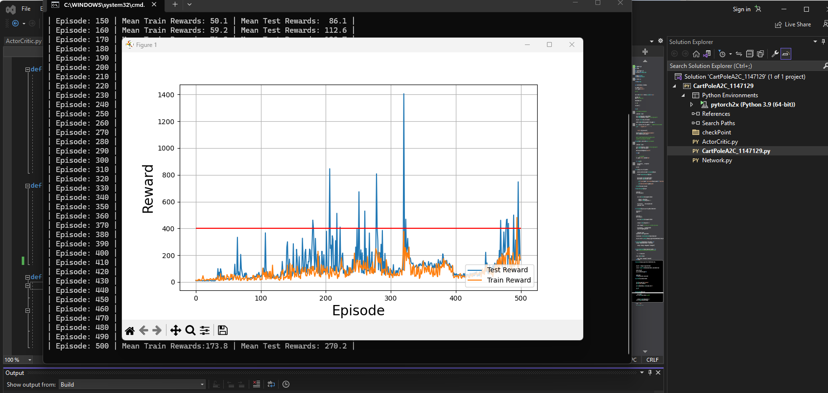
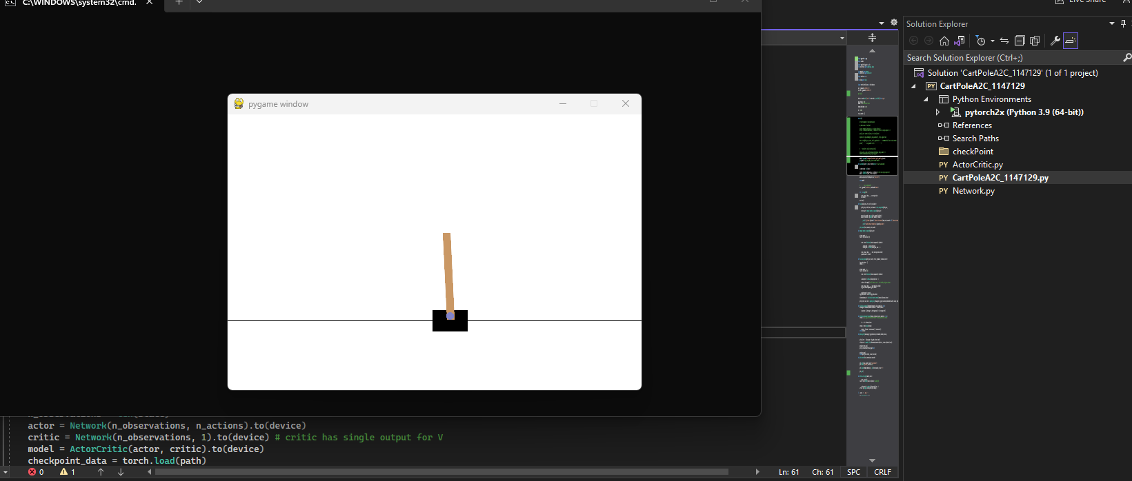
In this problem, I implemented the Advantage Actor-Critic (A2C) algorithm for the CartPole environment. I learned that A2C uses two networks: an actor, which selects actions, and a critic, which estimates the value of a state. This combination helps improve learning compared to using only a policy network.
I understood that A2C reduces the high variance problem of REINFORCE by using the advantage function, which is the difference between discounted rewards and predicted state values. This helps the model learn more stable and meaningful updates.
I also learned that A2C uses two loss functions during training. The policy loss updates the actor so that good actions become more likely, while the value loss updates the critic so that its state-value predictions become more accurate. This was an important learning point for me because it showed how both networks have different roles but are optimized together in one framework.
From this problem, I also observed that A2C provides more stable learning compared to REINFORCE. Because the value function reduces variance, the reward curve is generally less noisy and the agent learns a good balancing policy faster. Overall, this problem helped me better understand actor-critic methods, the role of the advantage function, and why combining policy learning with value estimation can improve reinforcement learning performance.

